**Case 7 –Business Rules and Conceptual Model**

Green Apple Healthcare

You are a Manger of nurses at Green Apple healthcare and today is your fist day. Your predecessor was preparing nurse rosters manually and keeping them in her office and at every end of the month she was taking two whole days off to finishing all the nurses’ earnings and their next month’s schedule.

Now, it is a good time to prepare your proposal to your boss because the hospital recently purchased a new enterprise system and external design group working with all departments with their needs.

Your Rules are very clear:

1.) Each nurse must have a night shift at least once each month.

2.) You have 42 nurses both male and female and they are working only 3 days a week.

3.) At least 2 Nurses should be available to substitute

4.) All nurses should substitute at least for one day a month

5.) There should be 3 shifts a day

6.) Each shift must be 8 hours long

7.) All supervisors report to the manager

8.) Each nurse must have a valid SSN

9.) Each nurse must be assigned of at least 3 patient files

10.) All time slots of shift should be available in the EP system

11.) All nurses must have a unique ID number

12.) Substitute days should be separate from the 3 days of work per week

13.) All leaves should be recorded in the system

14.) Substitutes should take over if any nurse is on leave

15.) No more than eight nurses can work in the same time slot

16.) A nurse can work up to 40 hours a week

17.) Every nurse should have 1 supervisor

18.) Manager, Nurse and supervisor must give a valid First name, Initial and Last name

19.) The leave should not negate hours from the 40-hour requirement

20.) Each employee must fill a timesheet.

21.) Each manager must upload final Roster into the system

22.) A case can have more than one nurse assigned

23.) All cases should have one unique Id

24.) Patients involved in the case should have a room or bed assigned to them

NURSE ERD

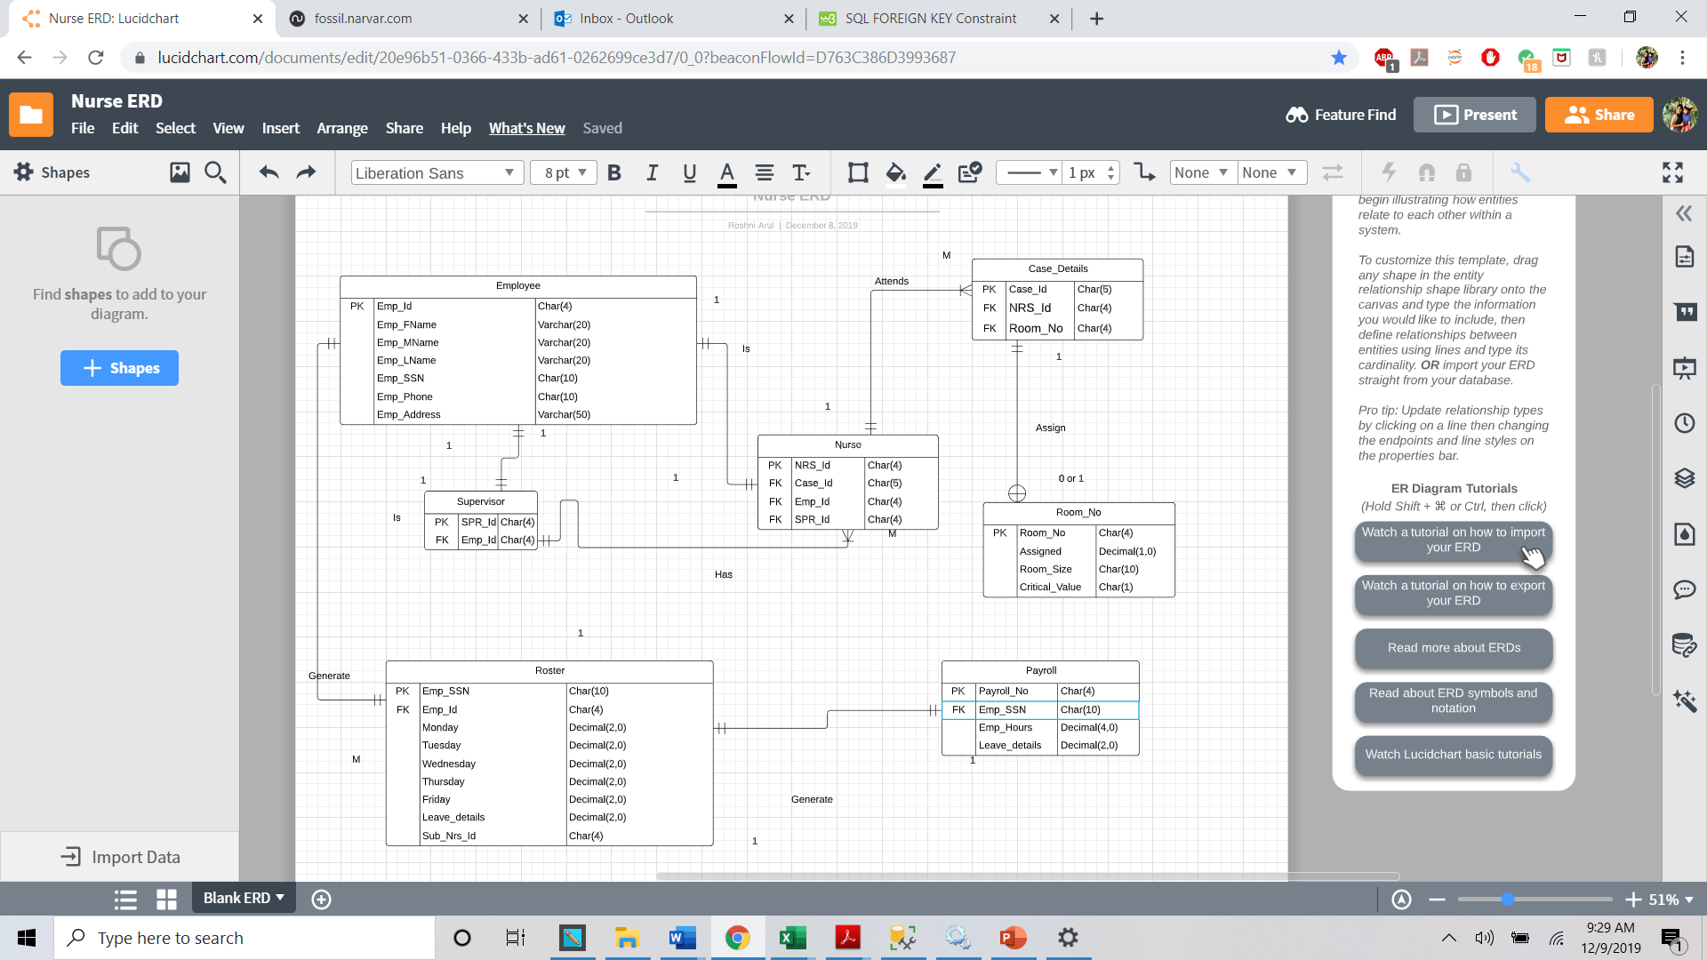

ERD Components

a. Entities

1. Employee
2. Supervisor
3. Roster
4. Nurse
5. Case
6. Room_No
7. Payroll

**b. Attributes of entities**

i. Attributes of Employee

|  |  |  |  |  |  |  |
| --- | --- | --- | --- | --- | --- | --- |
| Emp_Id | Emp_Fname | Emp_MName | Emp_Lname | Emp_SSN | Emp_Phone | Emp_Address |

Iii. Attribute of supervisor

|  |  |
| --- | --- |
| Emp_Id | Spr_Id |

iv. Attribute of Roster

|  |  |  |  |  |  |  |  |  |  |
| --- | --- | --- | --- | --- | --- | --- | --- | --- | --- |
| Emp_Id | HR_Id | Emp_Id | Monday | Tuesday | Wednesday | Thursday | Friday | Leave_details | Sub_Nrs_Id |

v. Attribute of Nurse

|  |  |  |
| --- | --- | --- |
| Emp_Id | Case_Id | Spr_Id |

vi. Attribute of Payroll

|  |  |  |
| --- | --- | --- |
| Emp_Id | Emp_Hours | Leave_details |

vii. Attribute of Case

|  |  |  |
| --- | --- | --- |
| Case_Id | Emp_Id | Room_no |

viii Attribute of Room.No

|  |  |  |  |
| --- | --- | --- | --- |
| Room_No | Assigned | Room_Size | Critical_Value |

c. Relationships

i. Supervisor has HR

ii. HR generates Roster

iii. Roster generates Payroll

iv. Nurse has supervisor

v. Nurse attends Case

vi. Case is assigned to Room_no

d. Cardinality of relationships

i. HR and Employee have 1 to 1 relationship

ii. HR and Supervisor have 1 to many relationship

iii. Roster and payroll have 1 to 1 relationship

iv. Supervisor and nurse have 1 to many relationship

v. Nurse and case have 1 to many relationship

vi. Case and room have 1 to 0 or 1 relationship

Flat Table

|  |  |  |  |  |  |  |  |  |  |  |  |  |  |  |  |  |  |  |  |  |  |  |  |  |  |  |  |  |  |  |
| --- | --- | --- | --- | --- | --- | --- | --- | --- | --- | --- | --- | --- | --- | --- | --- | --- | --- | --- | --- | --- | --- | --- | --- | --- | --- | --- | --- | --- | --- | --- |
| Emp_Id | | Emp_Fname | | | | Emp_MName | | | Emp_Lname | | | | | Emp_SSN | | | Emp_Phone | | | | Emp_Address | | Spr_Id | | Emp_Id | | | Emp_SSN | | |
| Emp_Id | | | Monday | | | Tuesday | | | Wednesday | | | | | Thursday | | | Friday | Leave_details | | | Sub_Nrs_Id | | | | | NRS_Id | | |
| Emp_Id | | Case_Id | | SPR_Id | | | | Payroll_No | | Emp_Id | | | Emp_Hours | | | | Leave_details | | | | Case_Id | | NRS_Id | | | Room_no | | | Room_No |
| Assigned | | Room_Size | | | Critical_Value | | | |

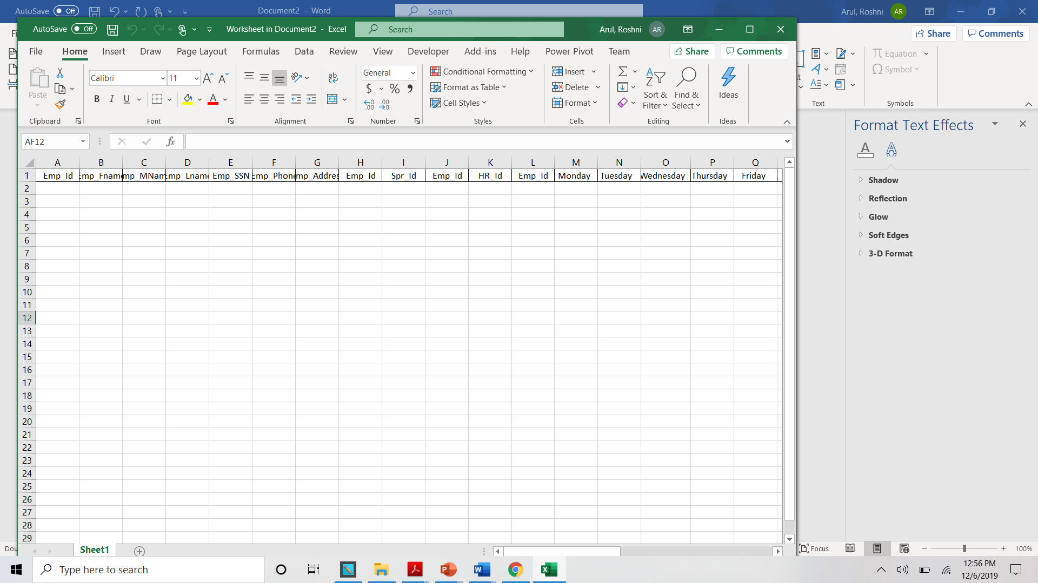

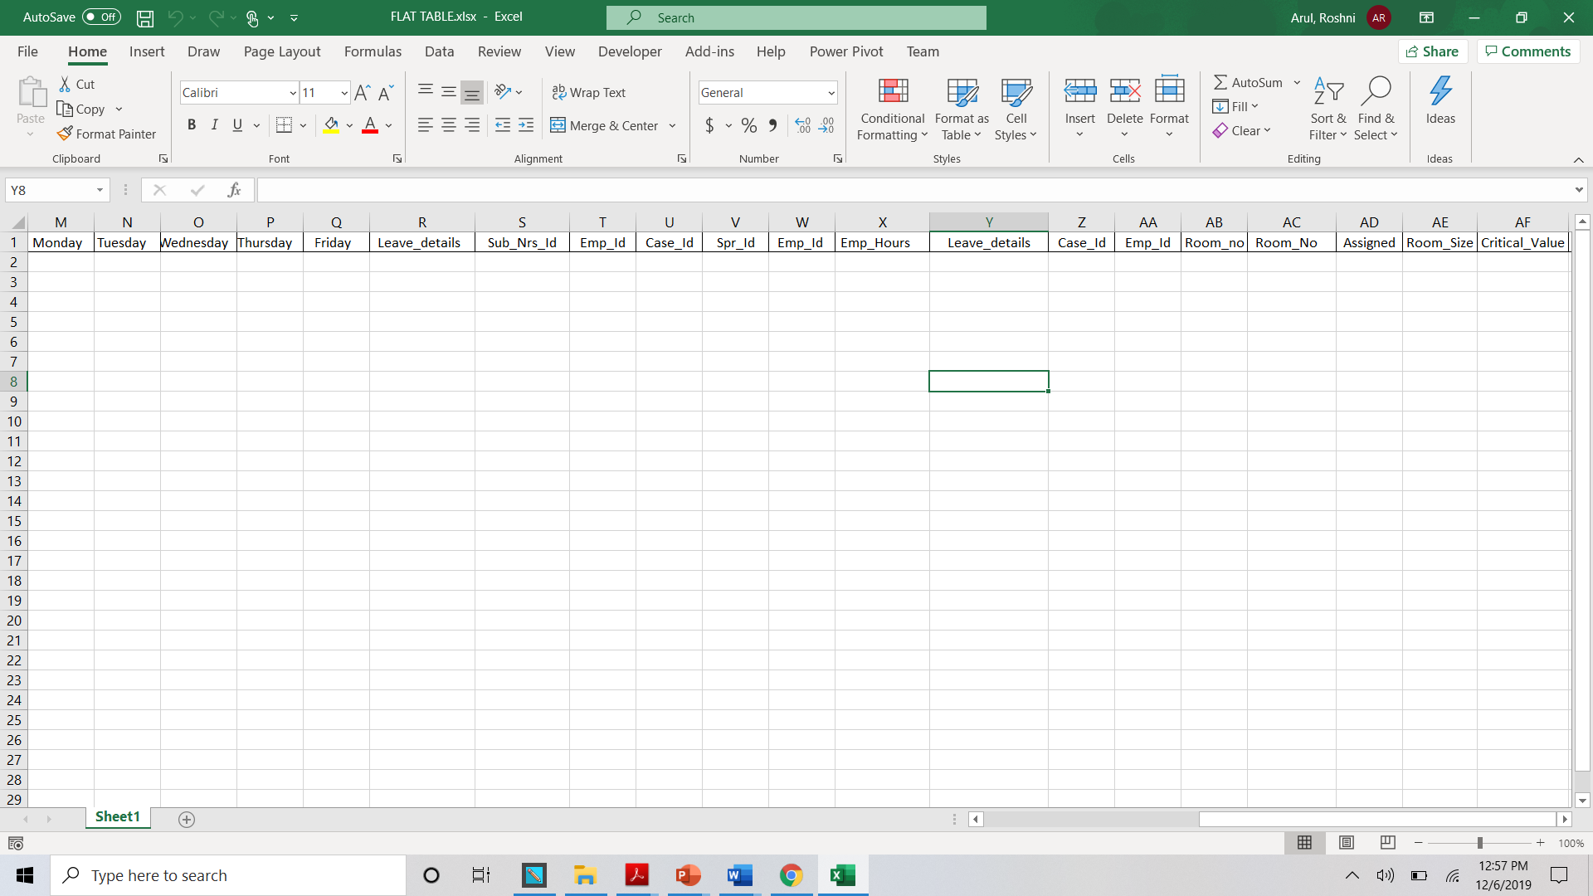

Normalization

Step 1:

**Initial Un Normalized Flat File**

The dependencies in the UNF are

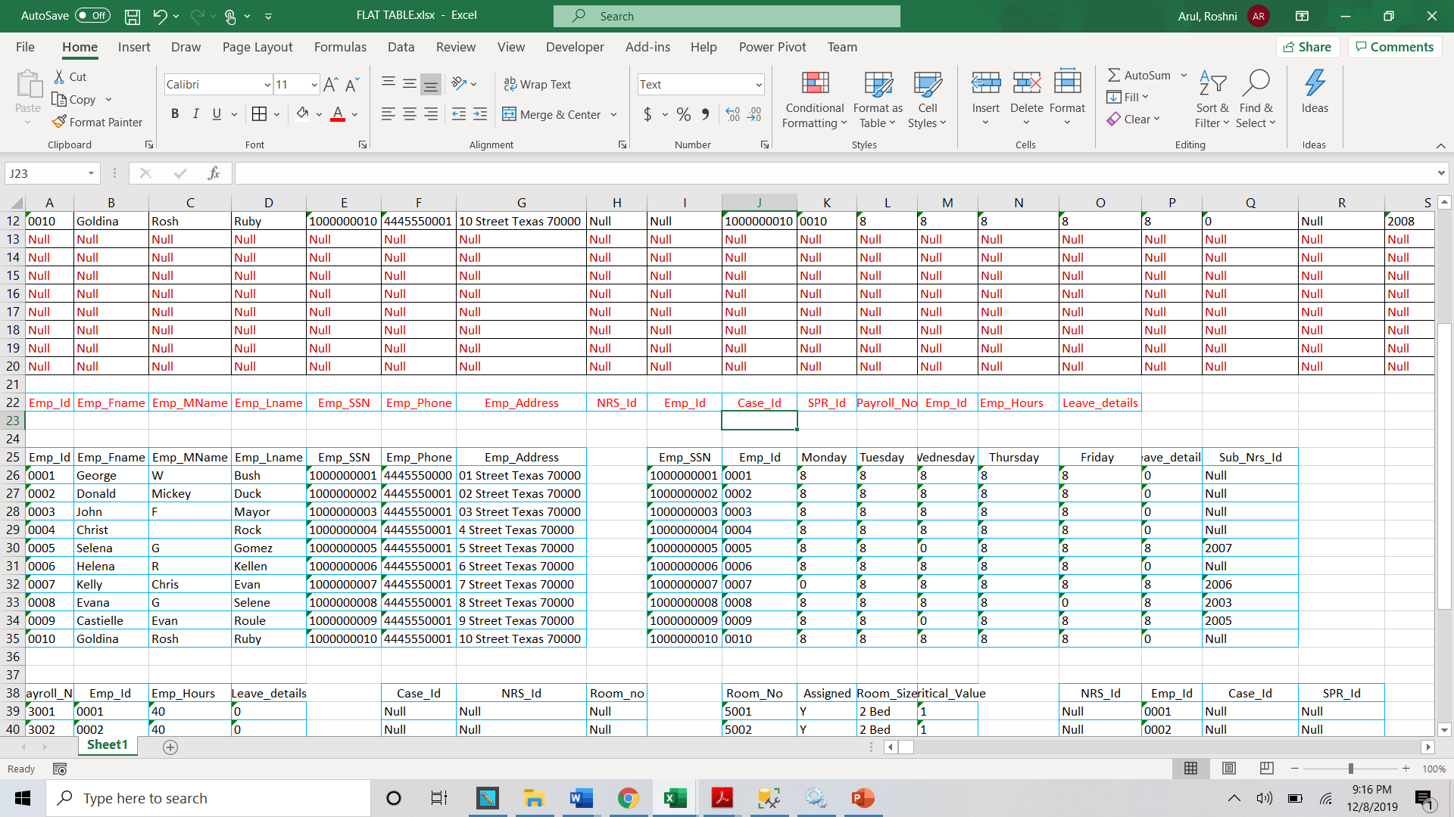

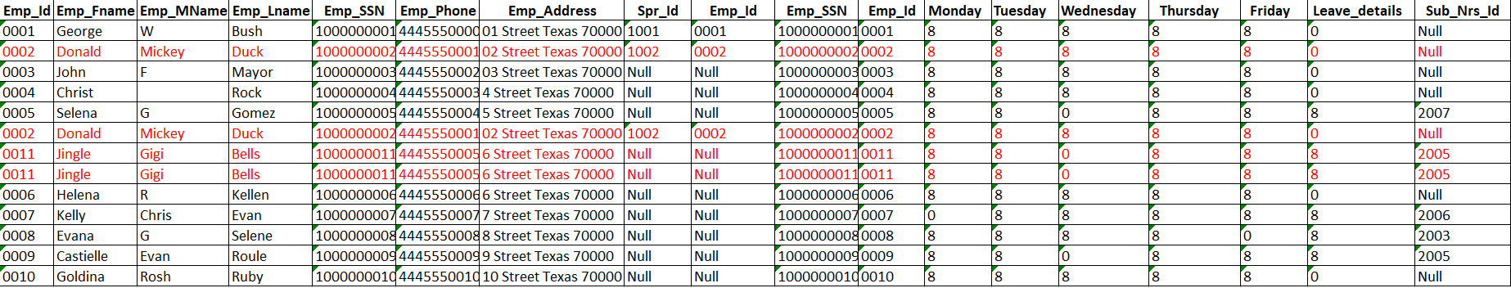

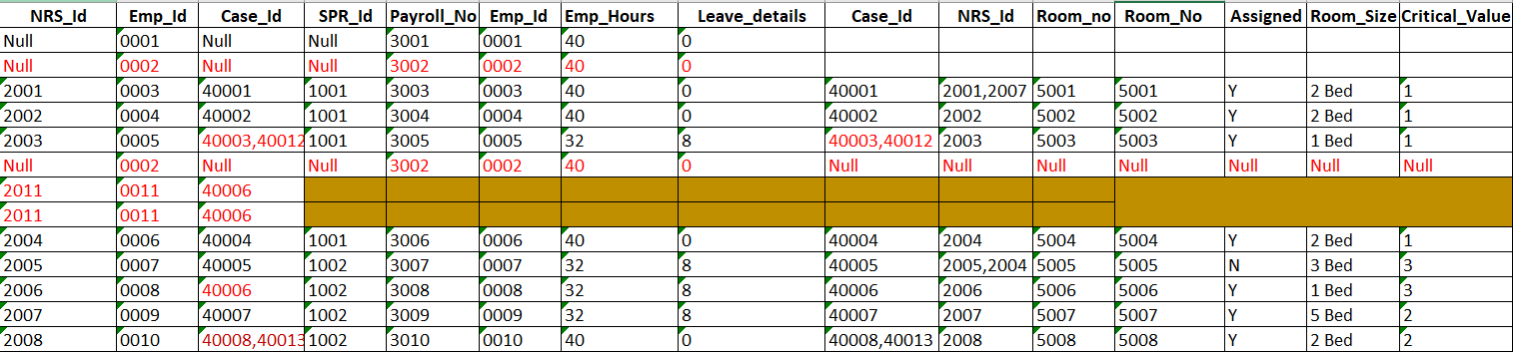

**1st Normalization Form tables**

**After deleting the repetitive rows and after splitting the multivalued columns The tables have become as shown below**

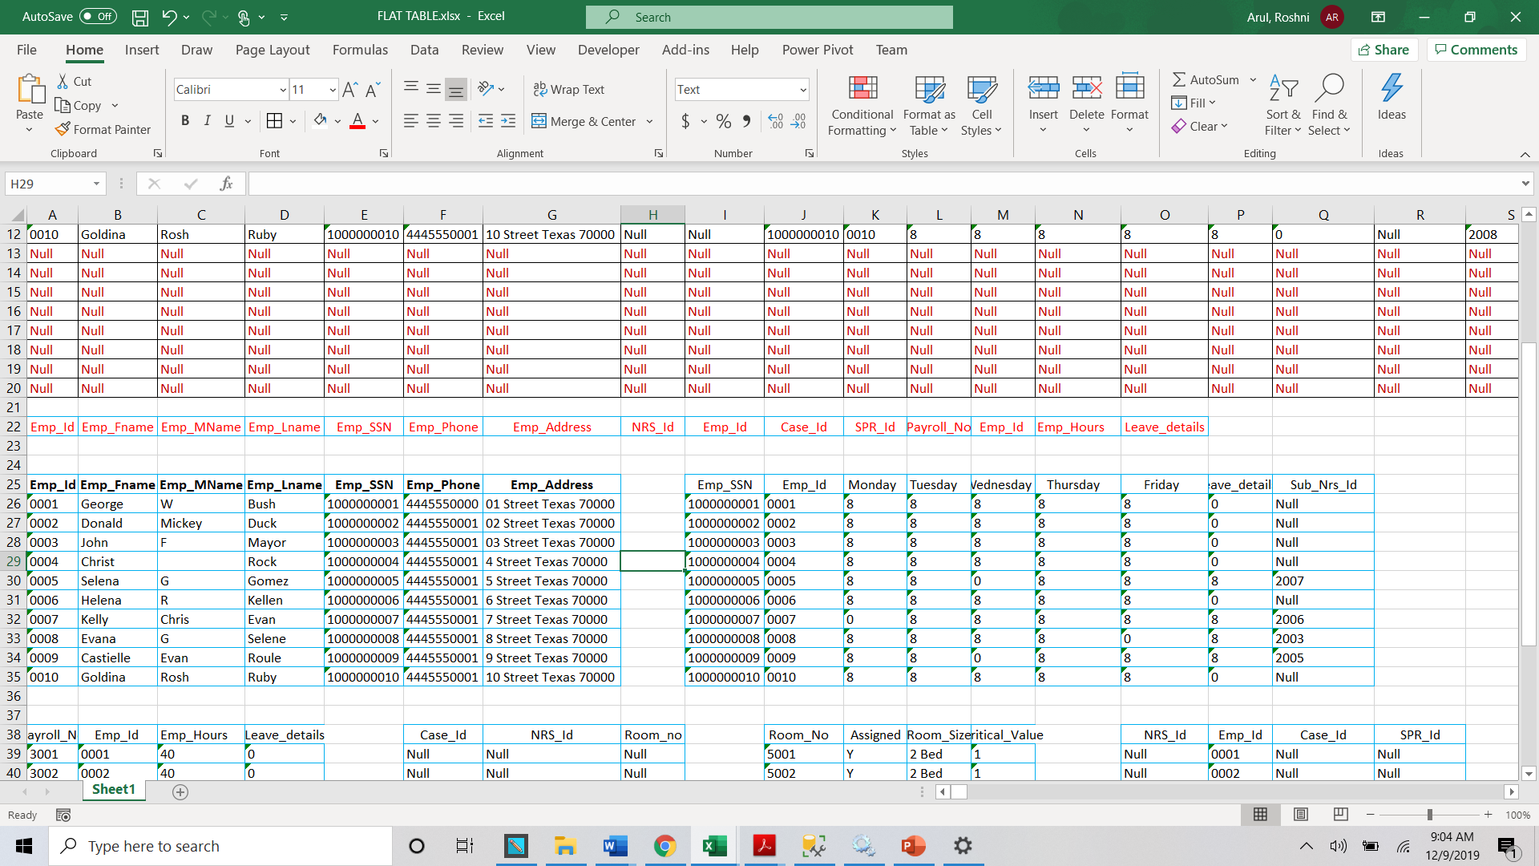

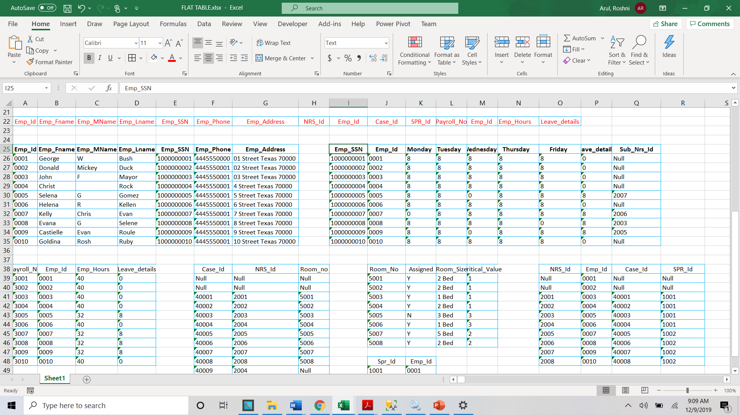

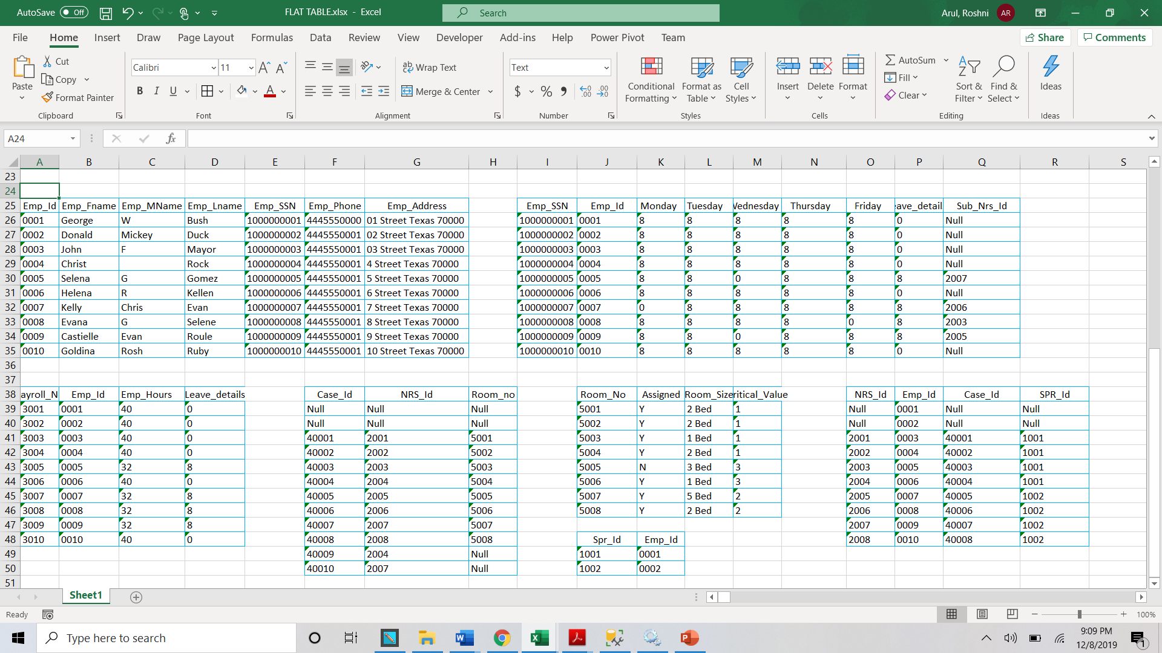

The Keys are shaded

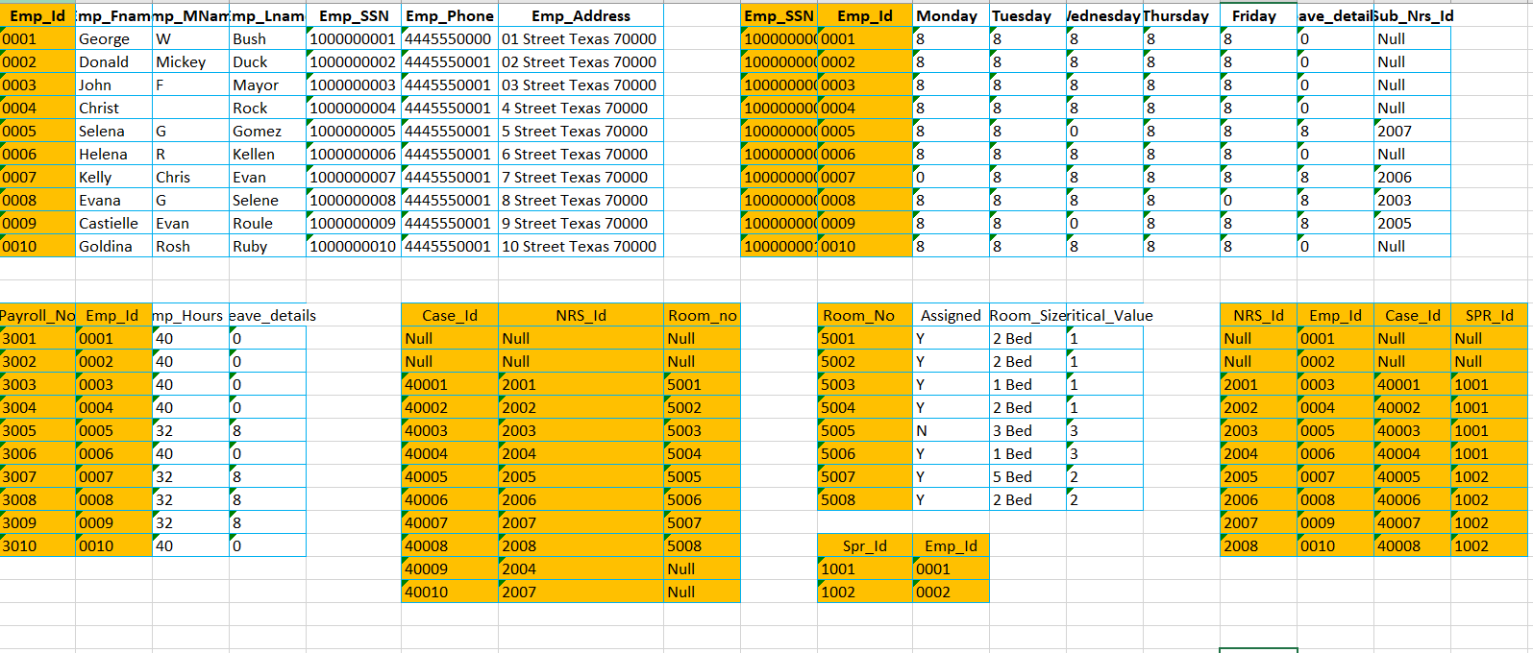

The above tables are now in 1 NF

**2nd Normalization form**

The below tables have atomic primary keys and so are already in 2 NF

1. Employee
2. Supervisor
3. Nurse
4. Case
5. Room_No

The below tables have composite primary keys and so we should remove the partial dependencies to bring them to 2 NF

1. Roster
2. Payroll





The partial dependencies are now removed and the tables are in 2 NF

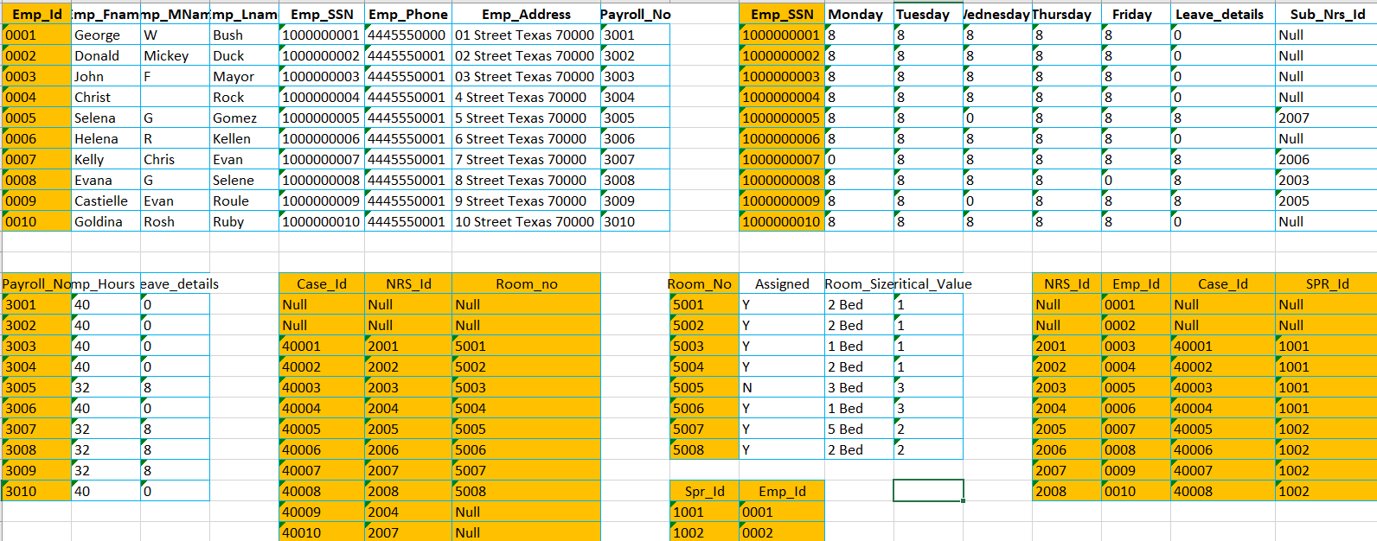

There are no transitive dependencies in the table and so we stop our normalization process here

Final ERD

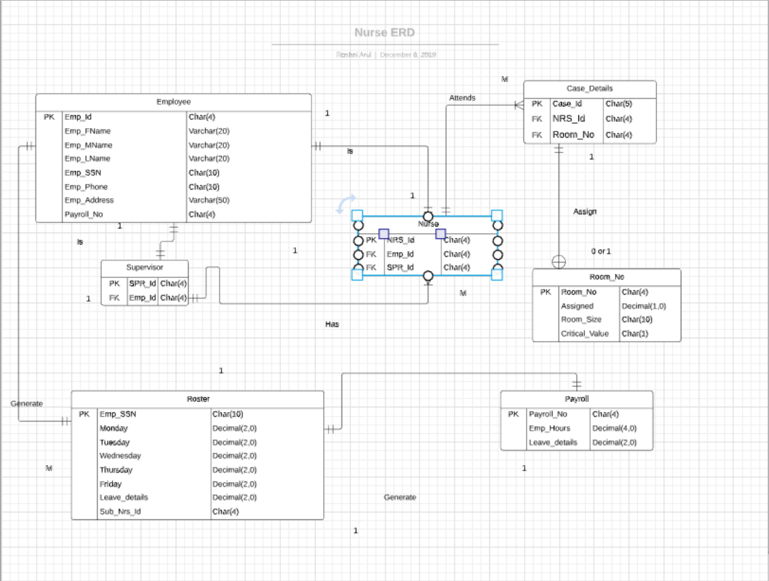

**SQL Scripting**

1. Create Database

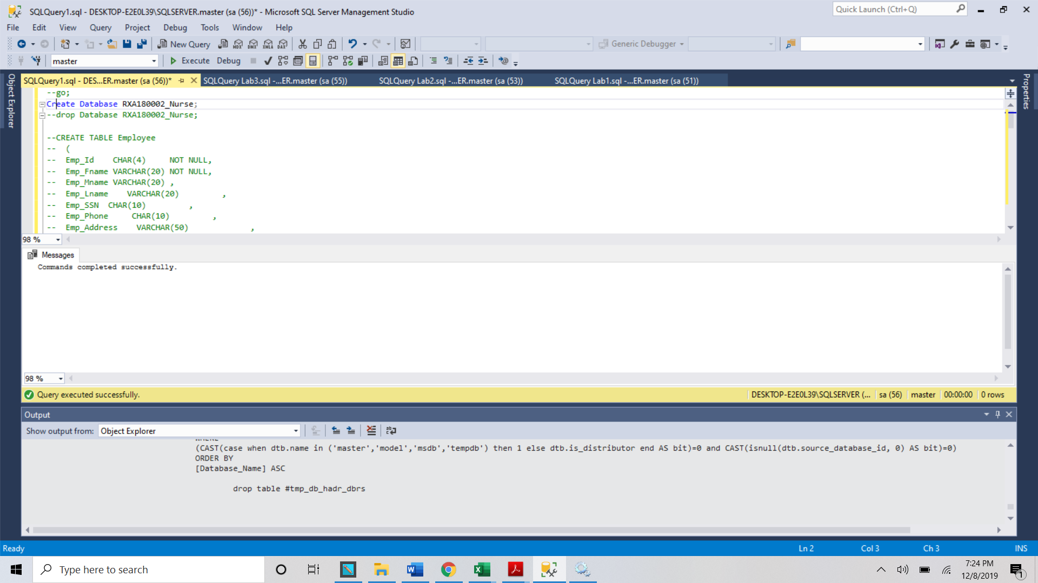

2. Create Tables without Index, PKs, and FKs ; 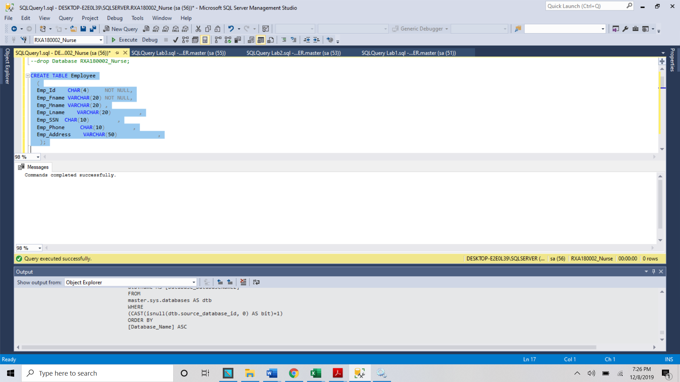 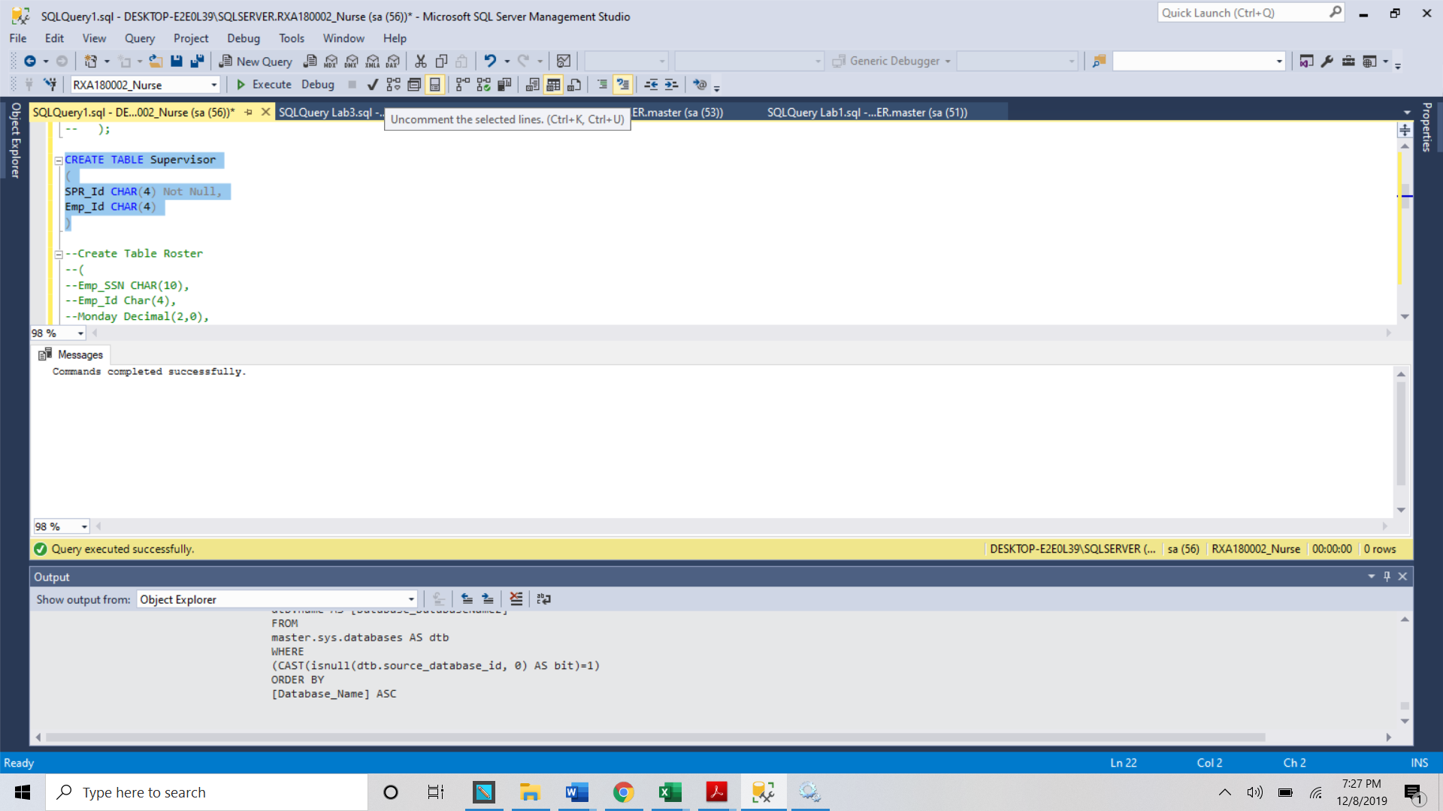 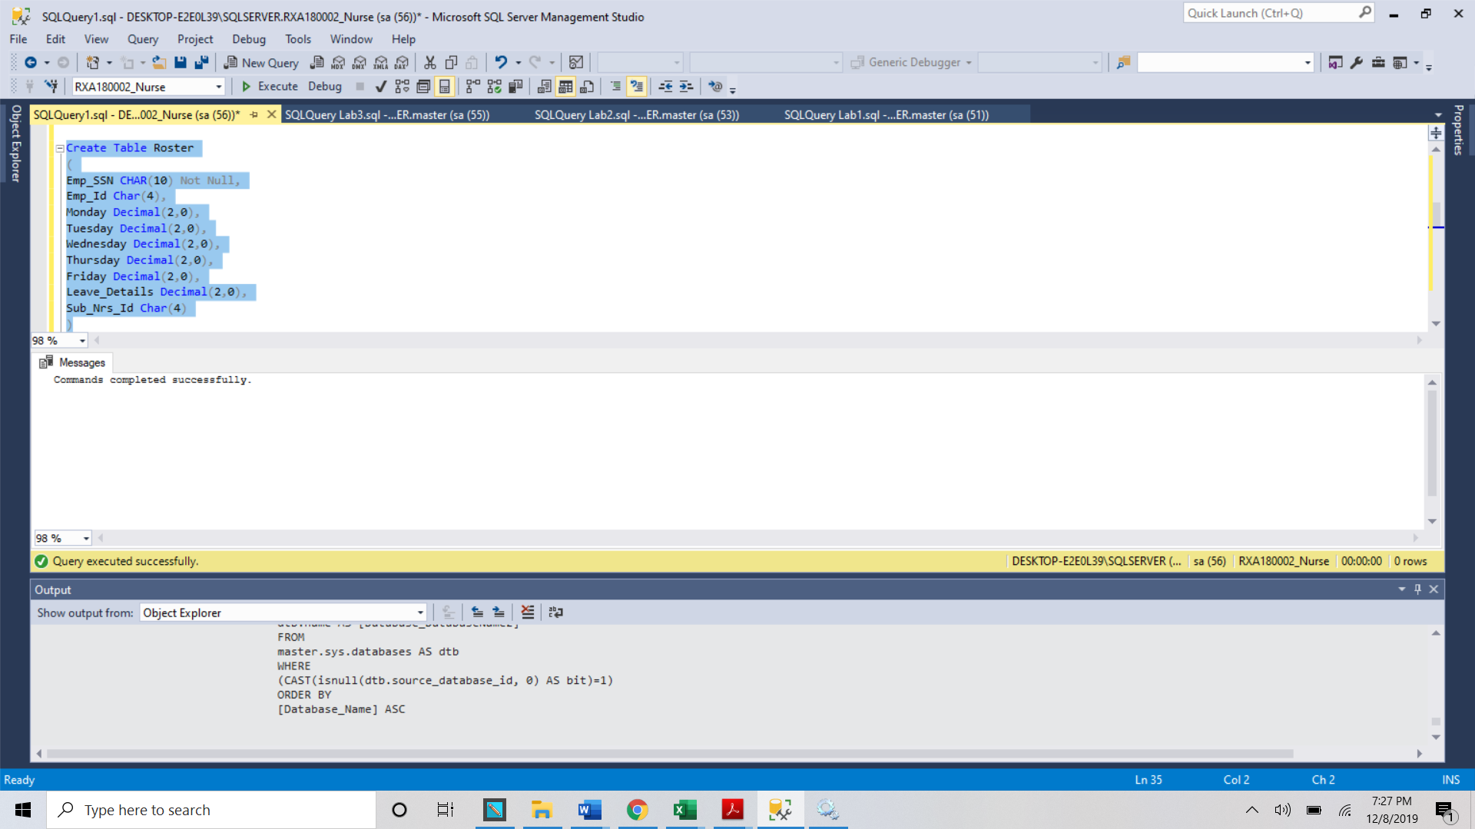 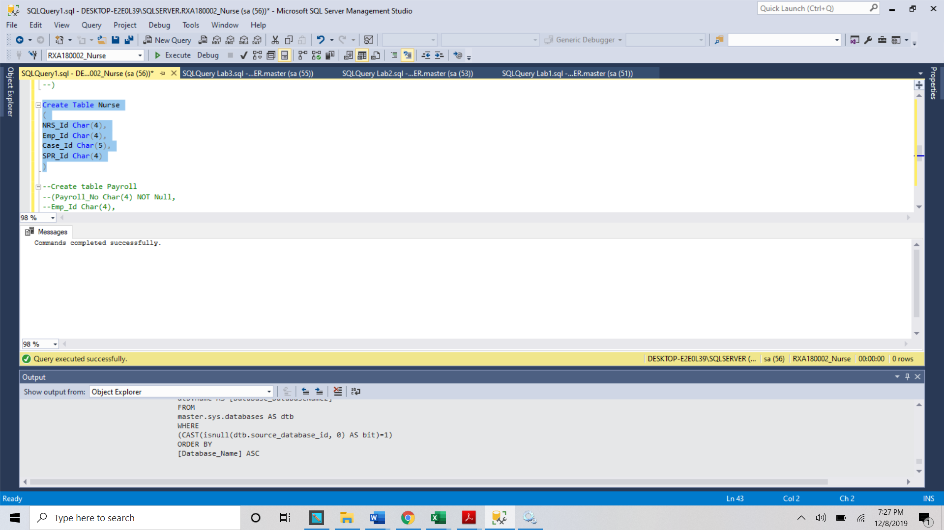 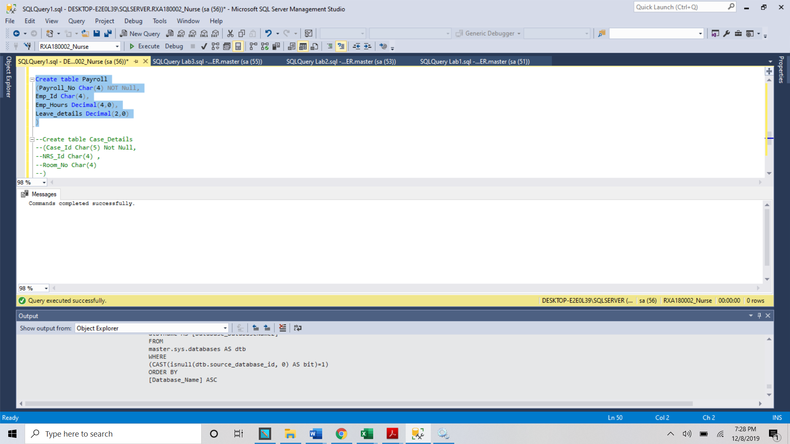 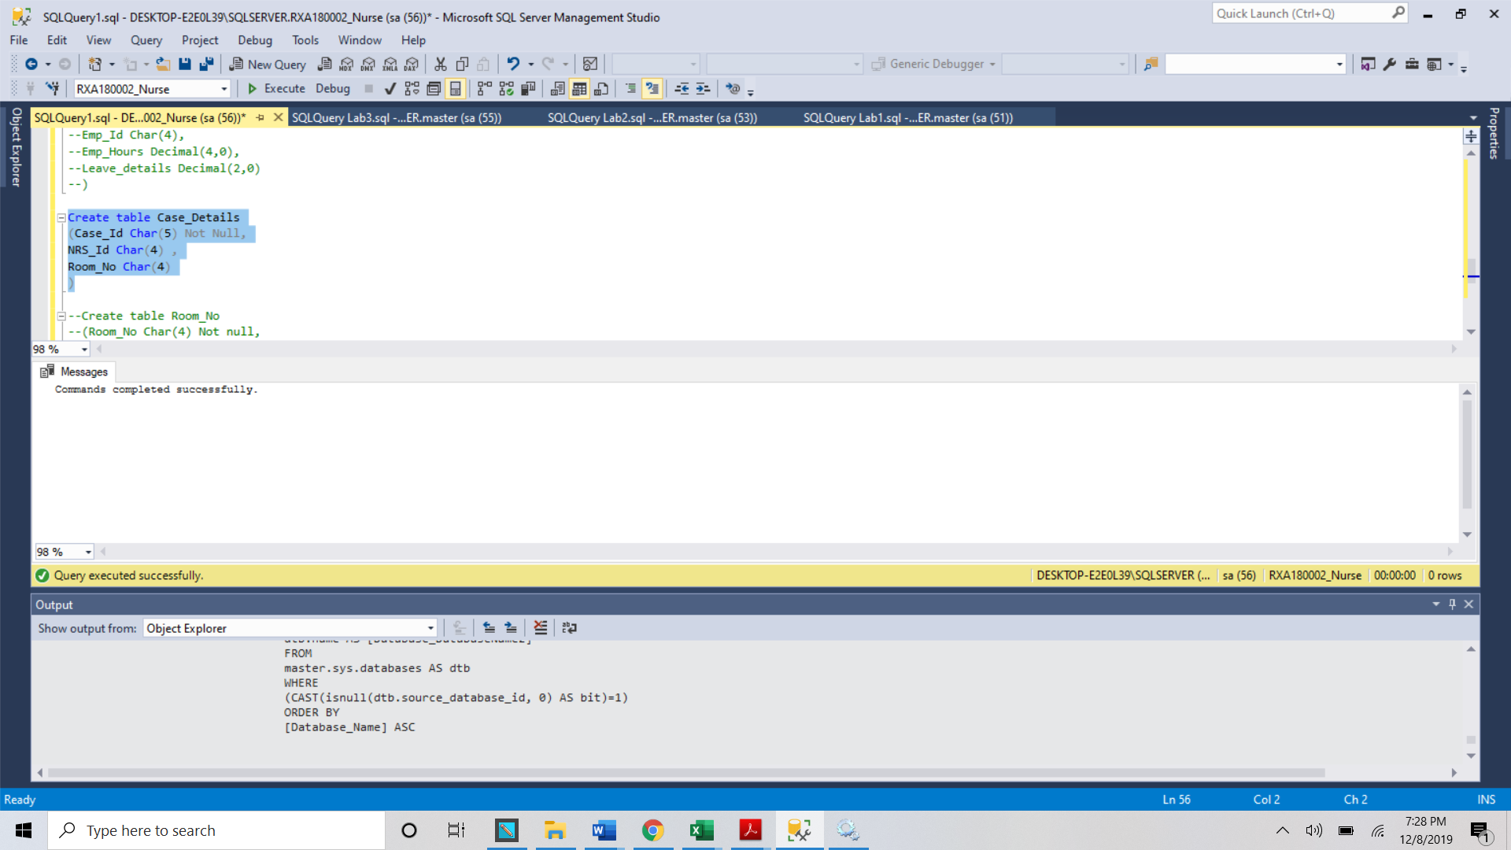 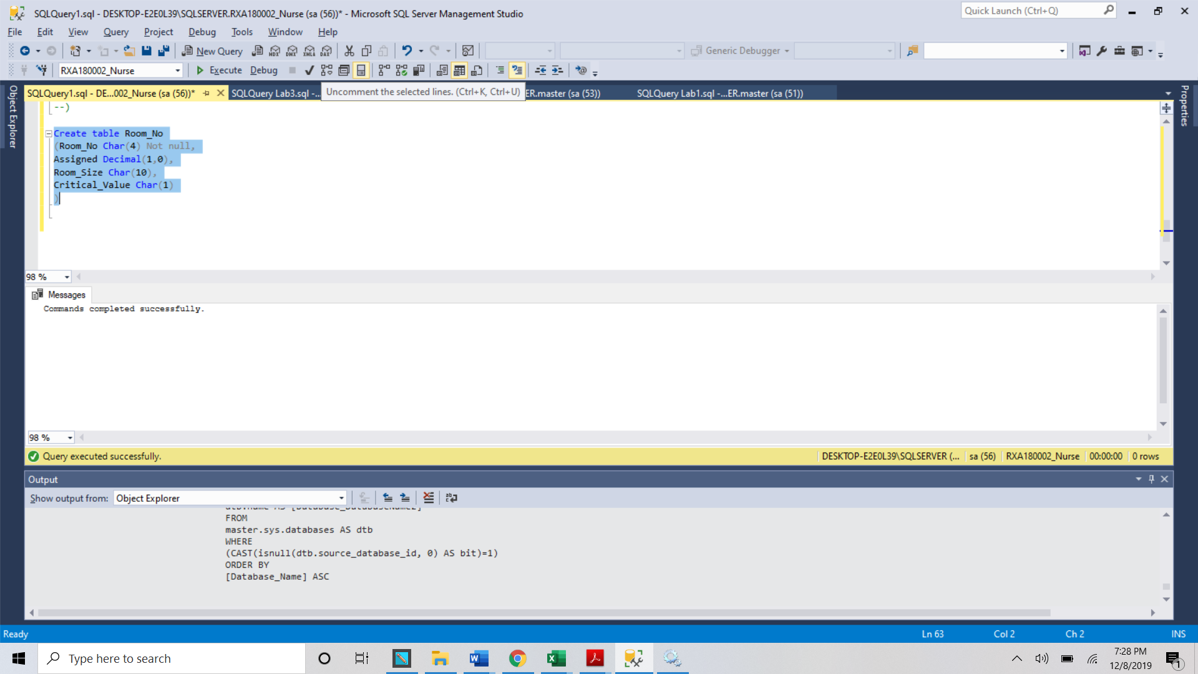 a. Define which entities will be your PK and Fks and make them “Unique” during to DDL

statement.

b. If you have any “Constrains” go ahead create in this stage.

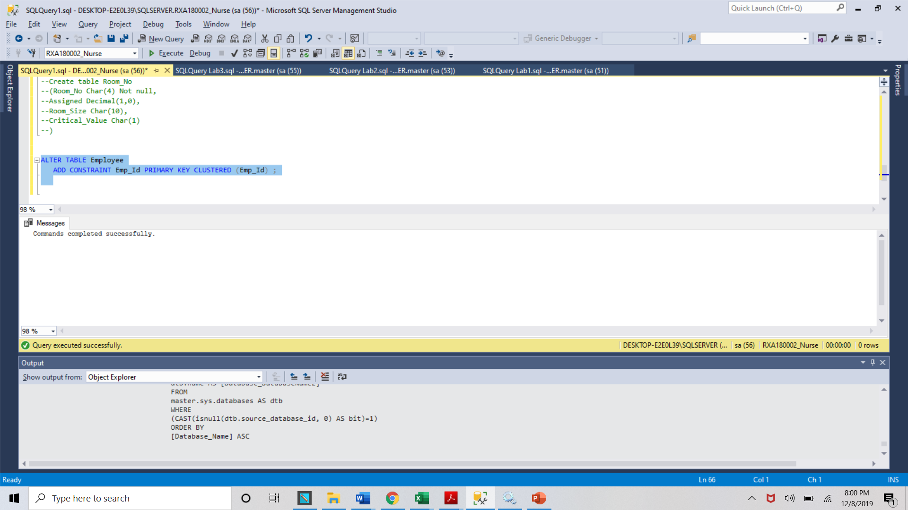 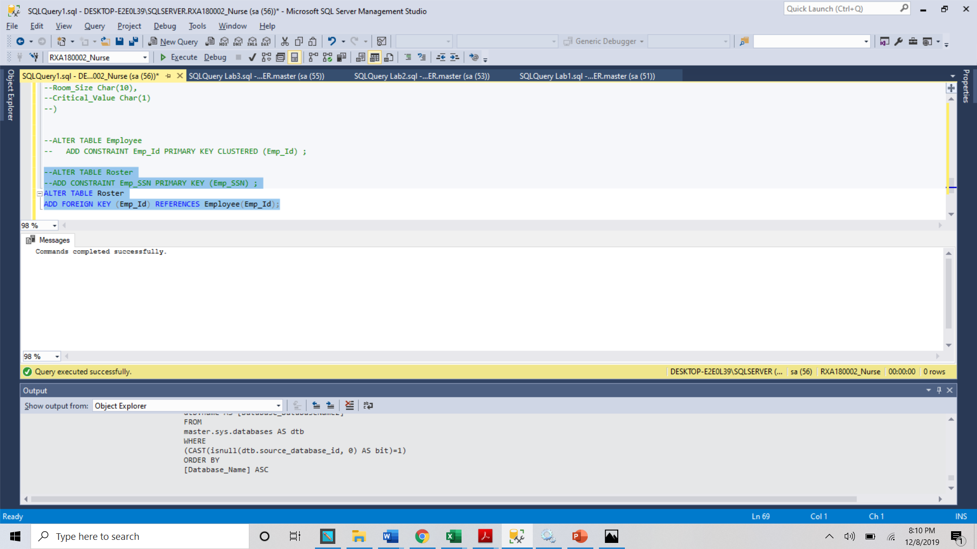 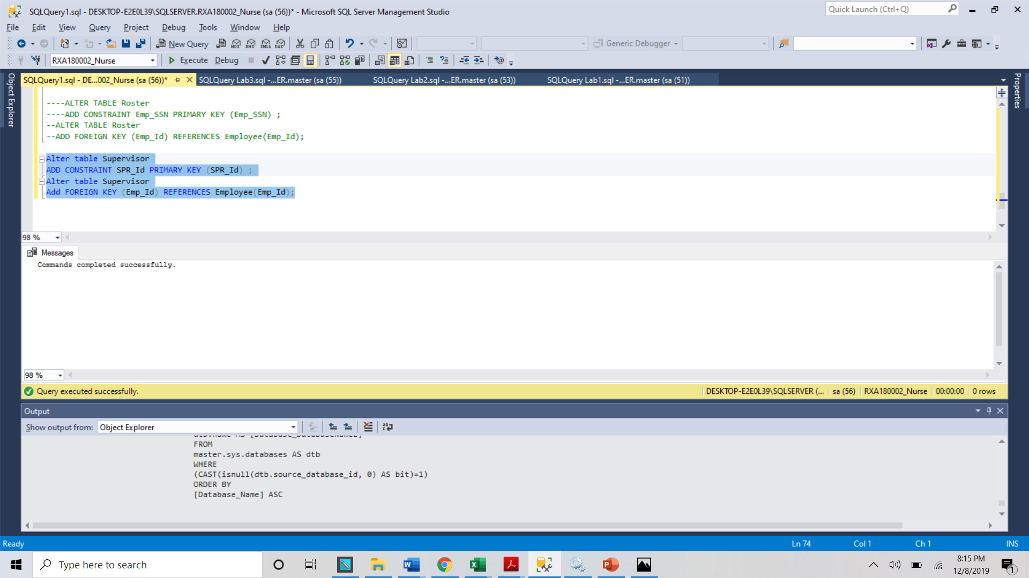 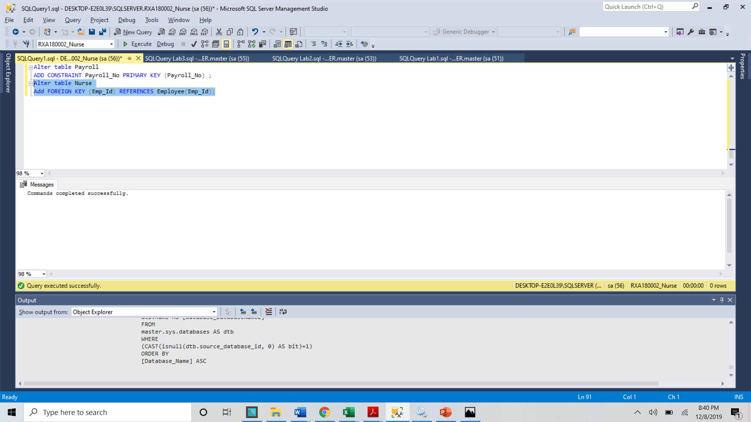 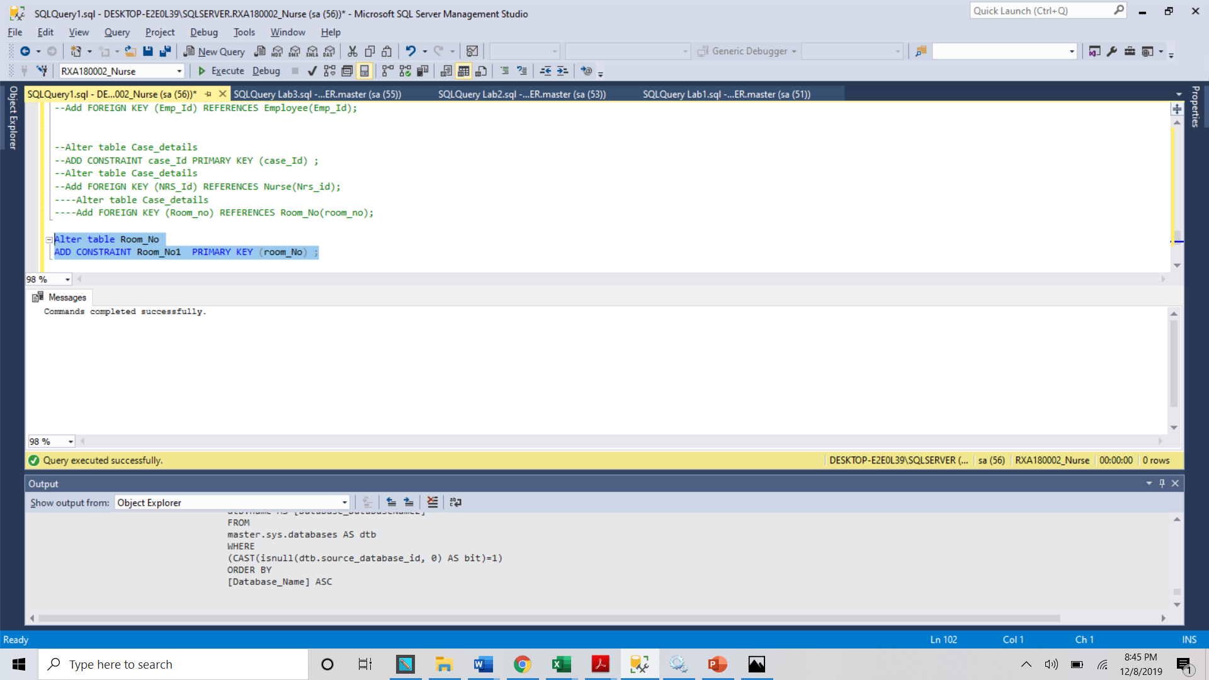3.

4. Start inserting data in each table make sure referential integrity in place

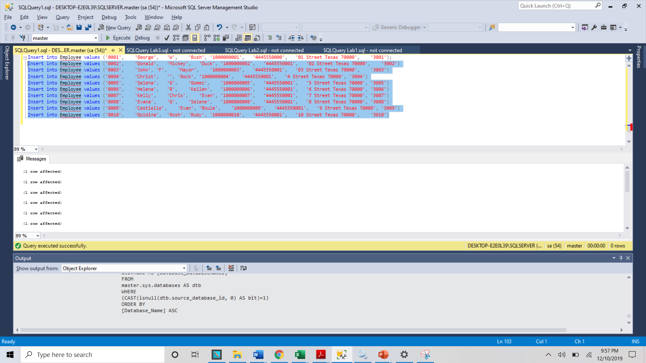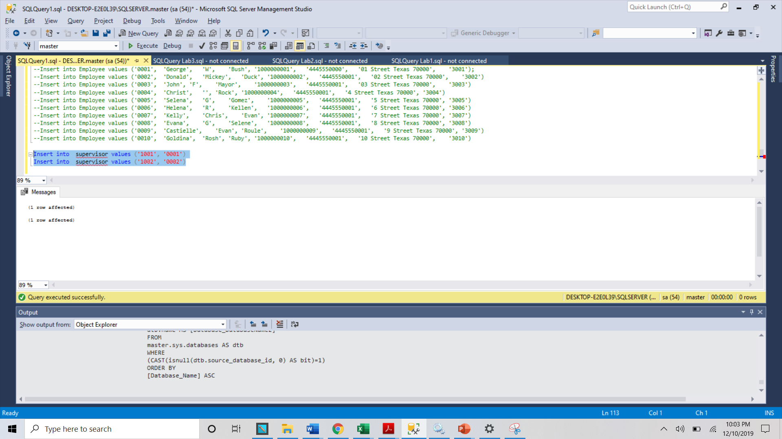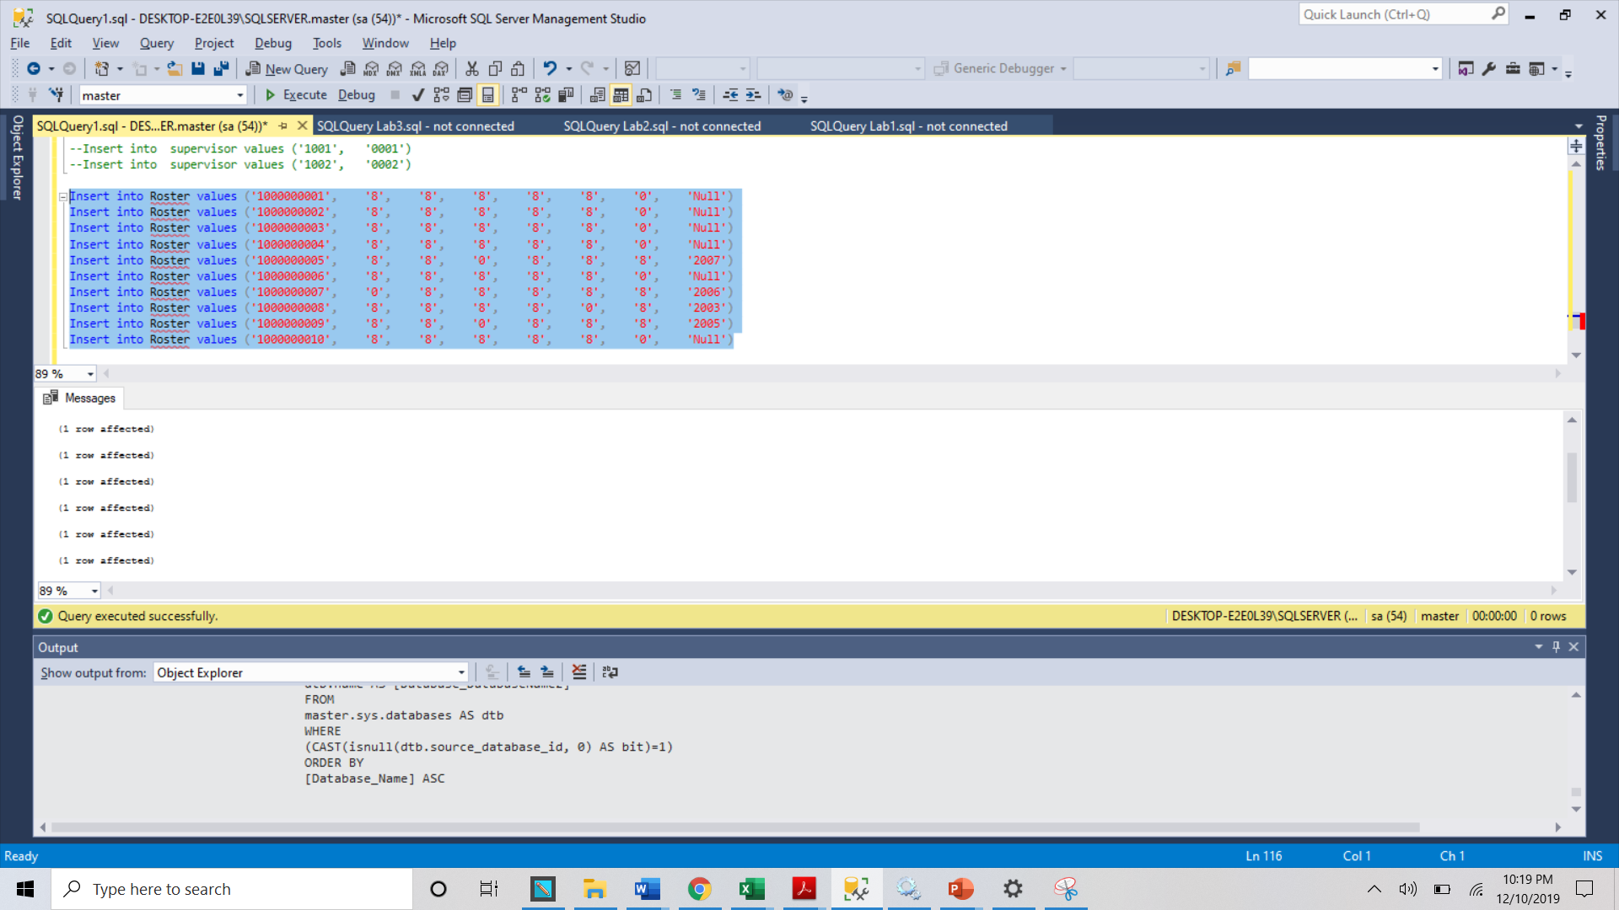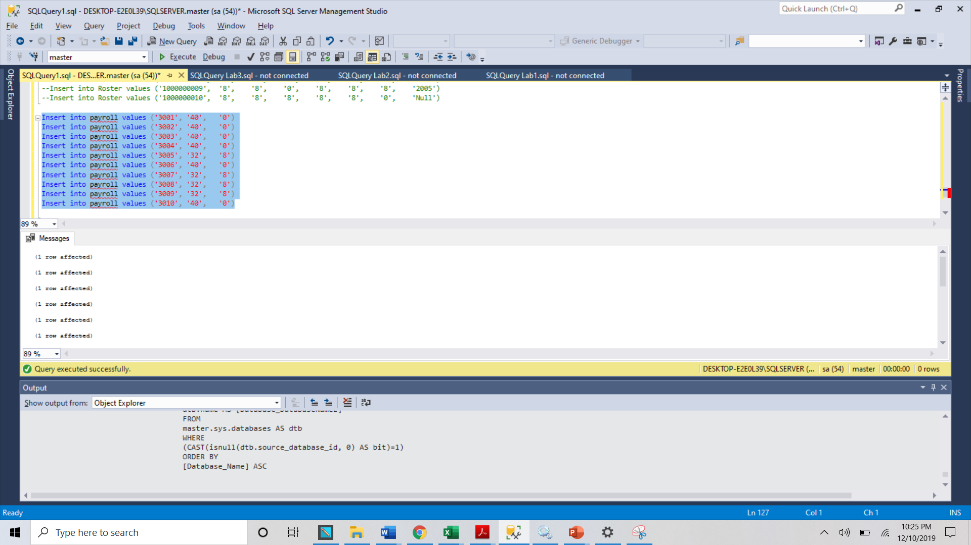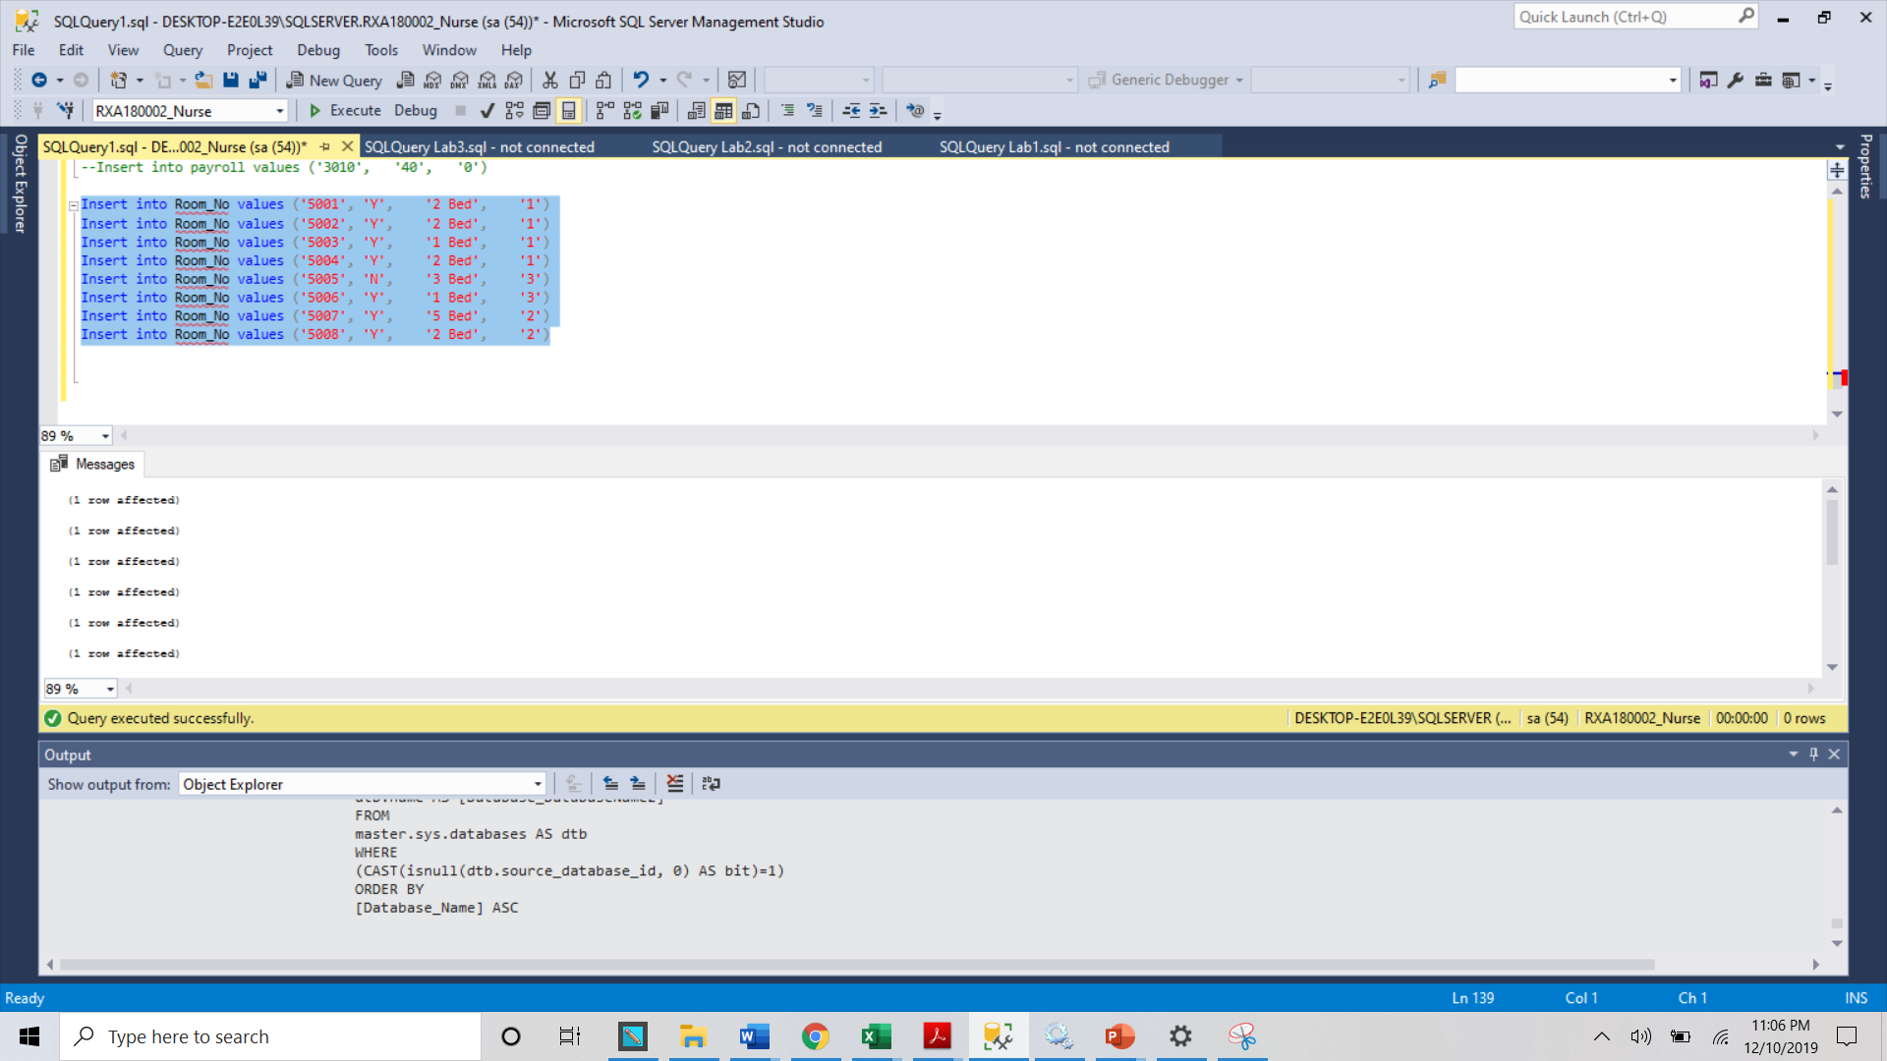

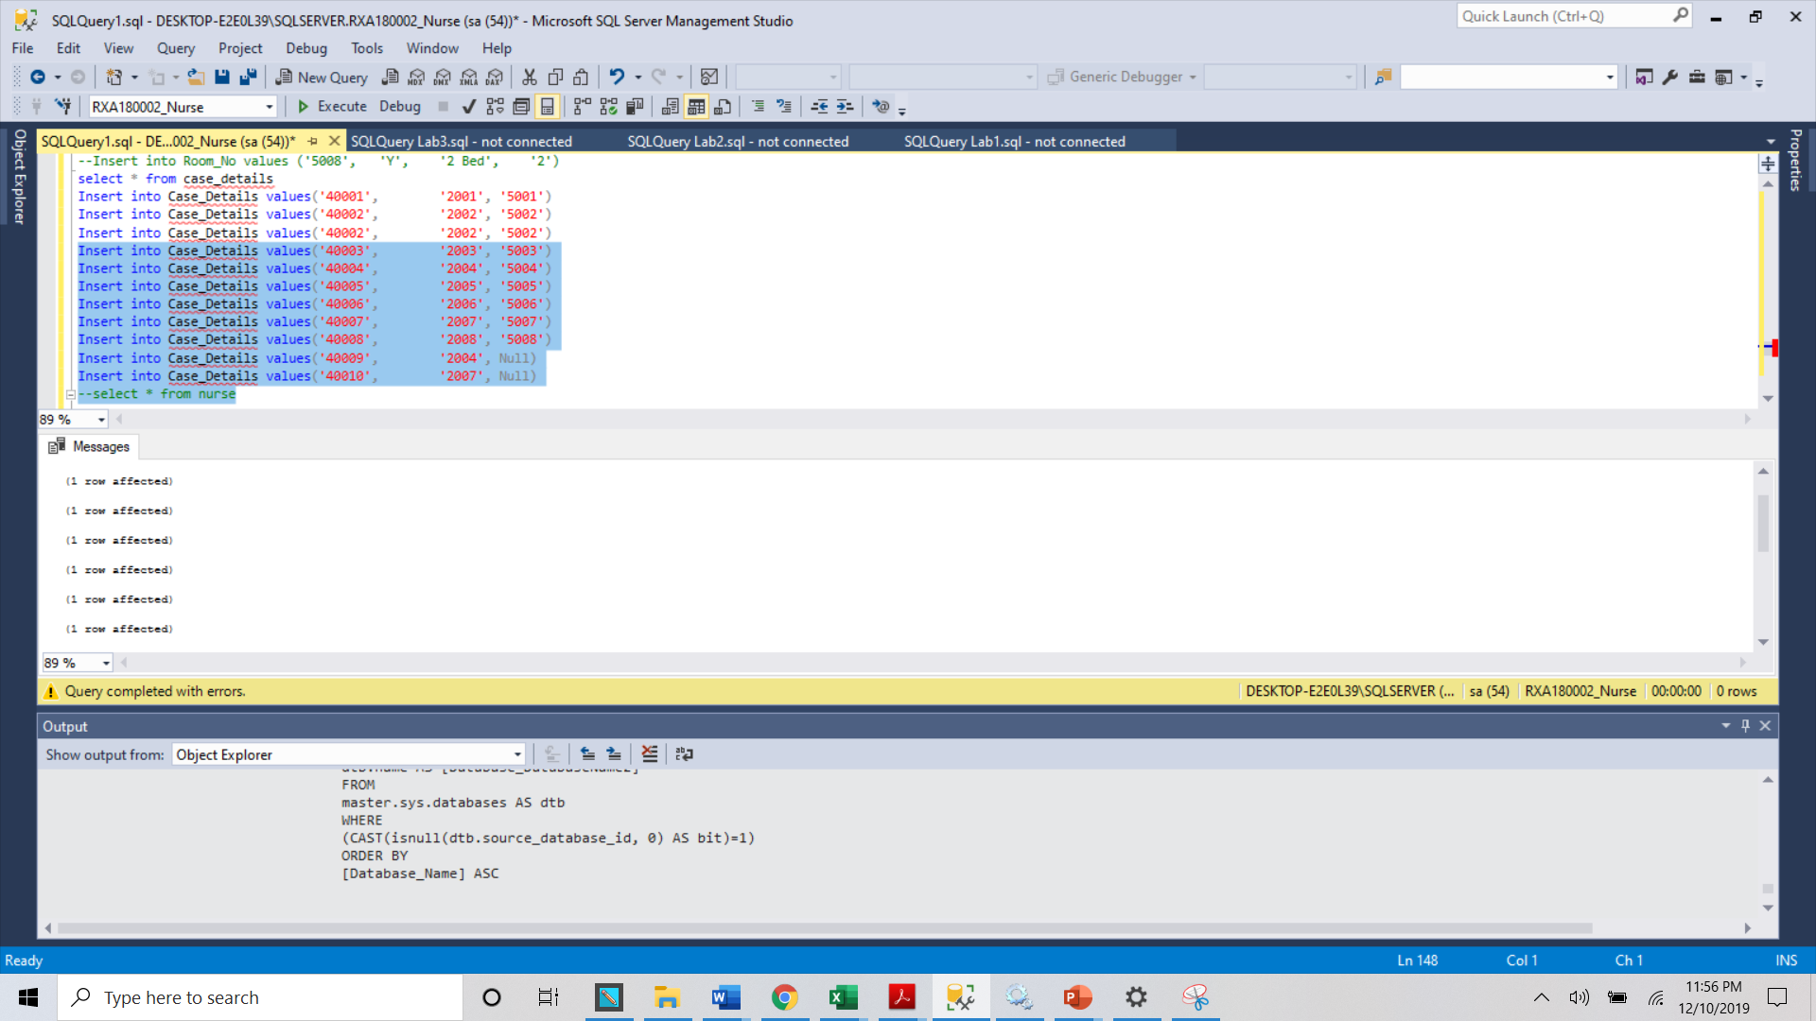6. Chose at least 2 tables from our project and ;

a. Show your table records;

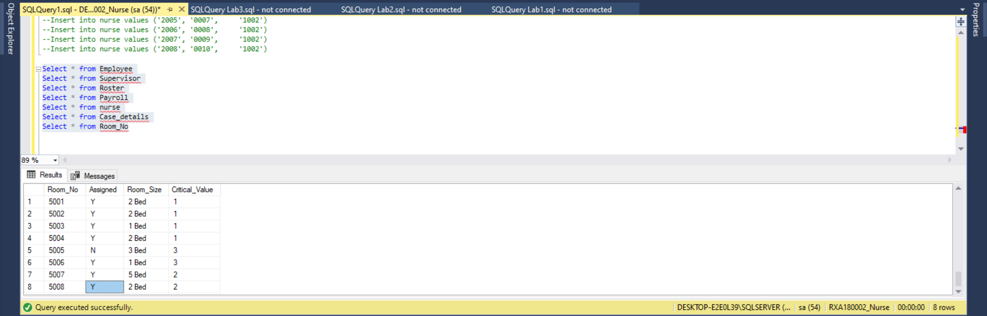5. Test your data, are they in place correctly?

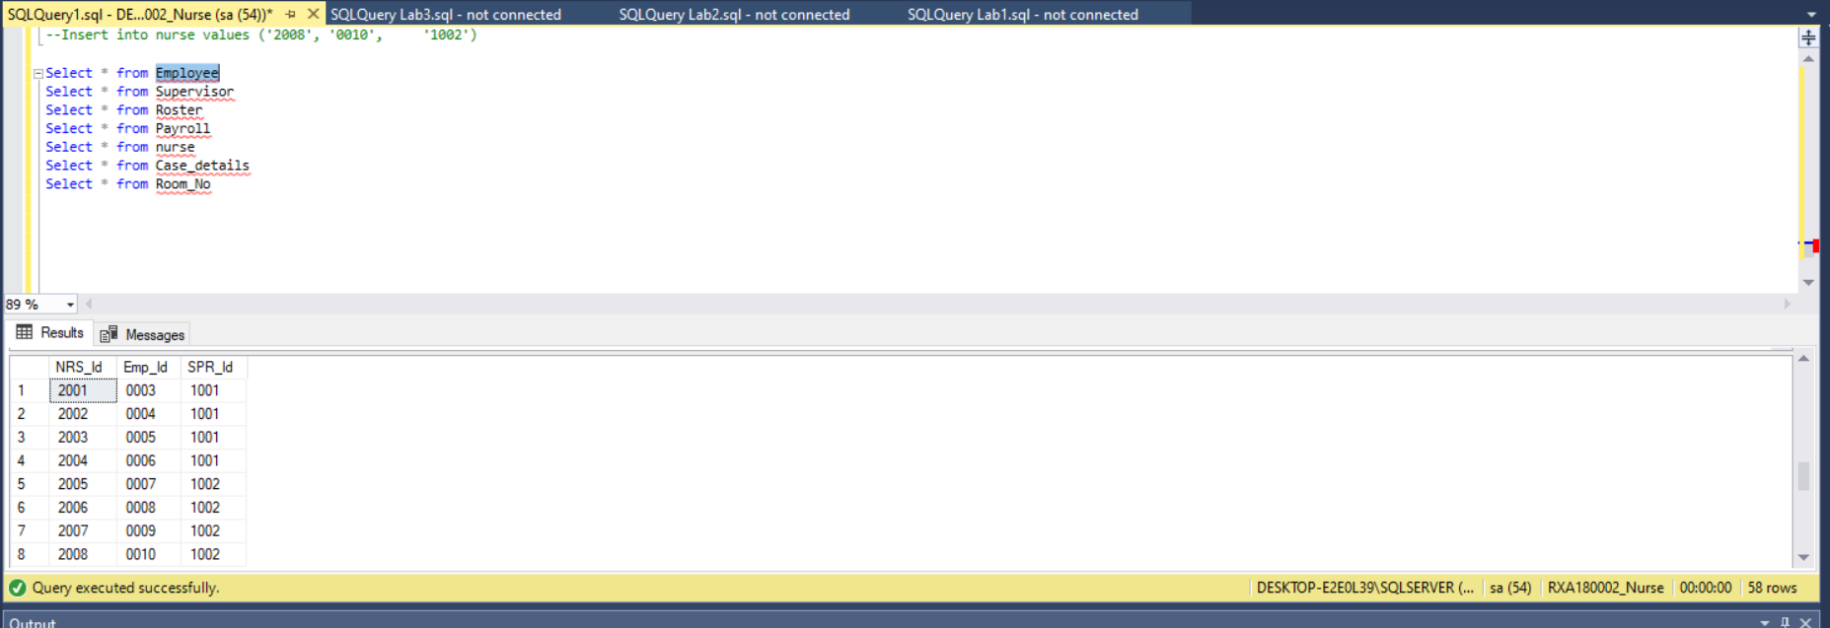 b. Create inner joins between two tables 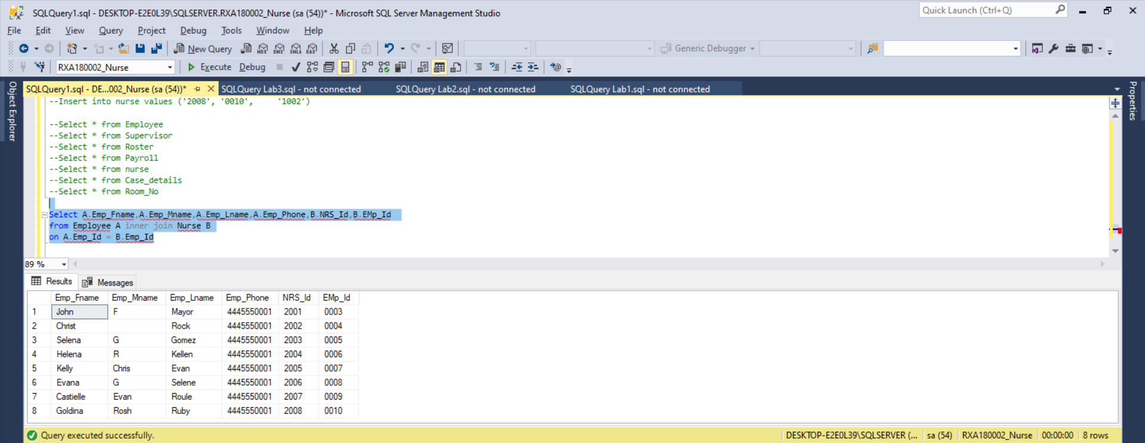

c. Create full joins between two tables

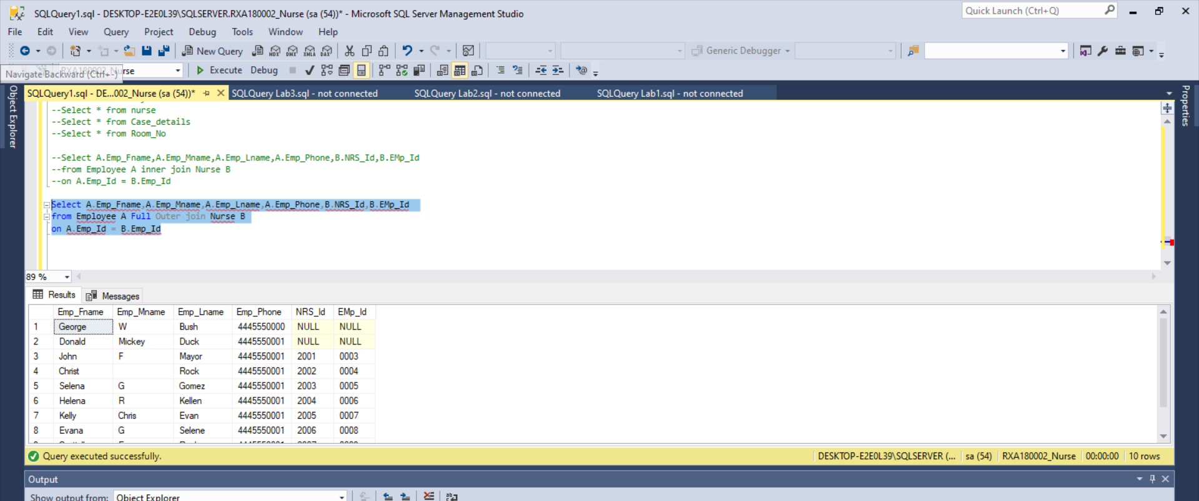

d. Create left outer joins between two tables

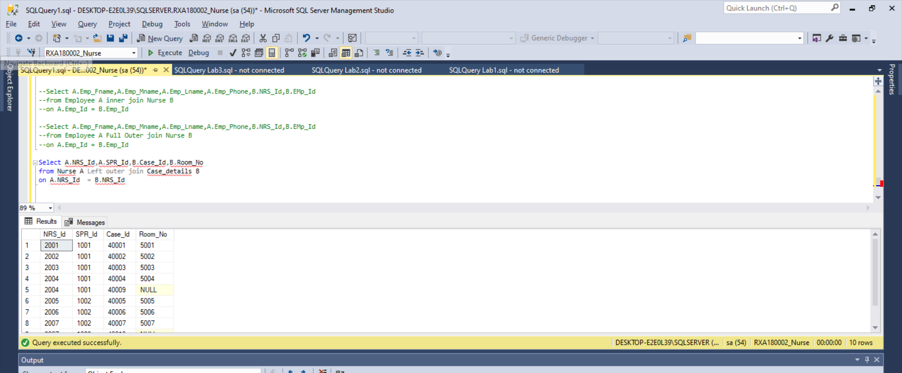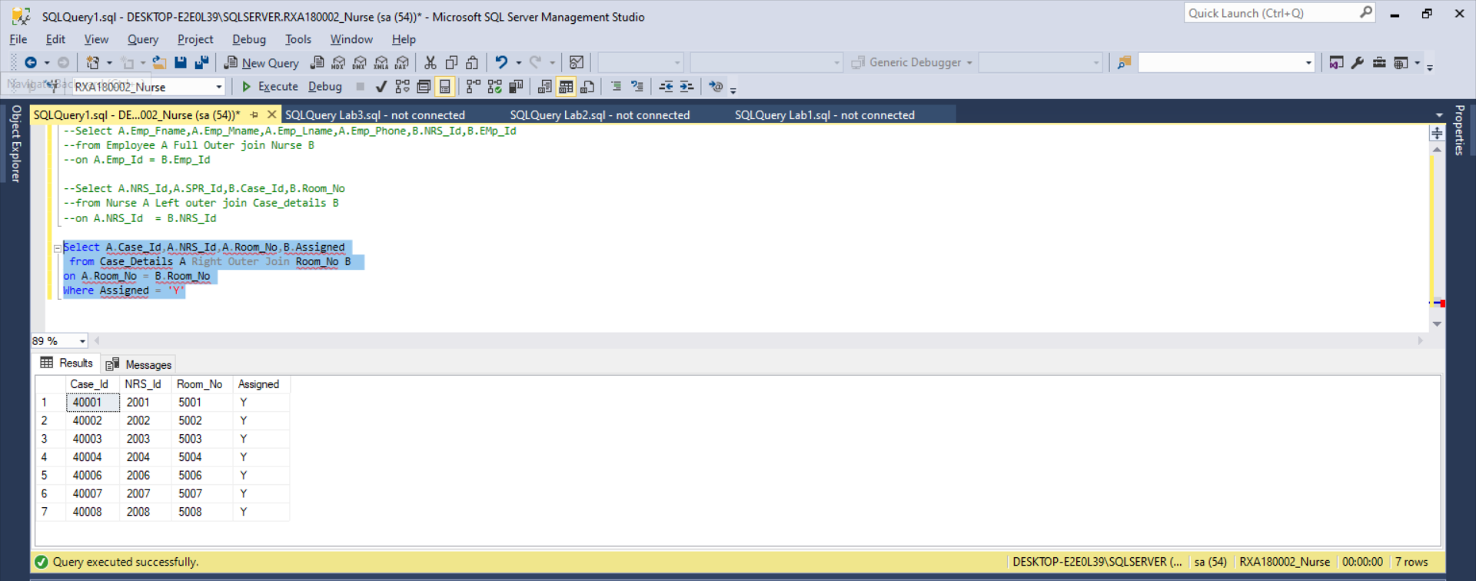 f. Create intersect between two tables

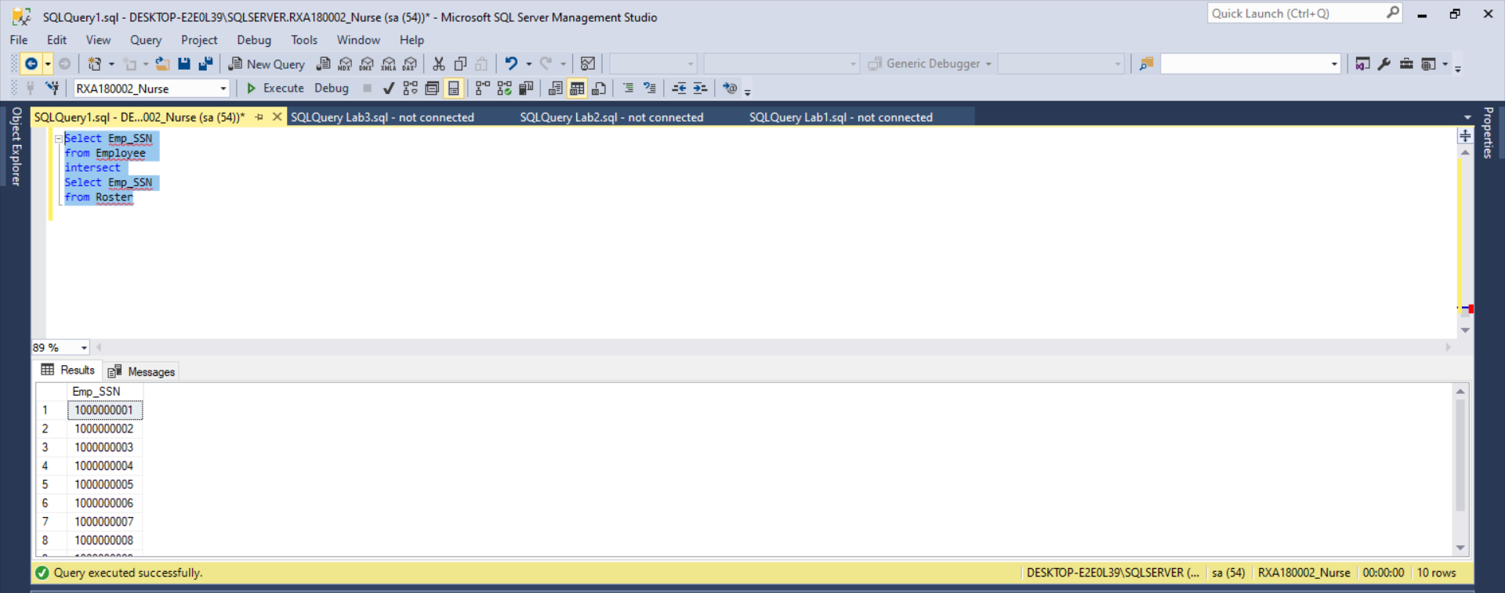 g. Create union between two tables

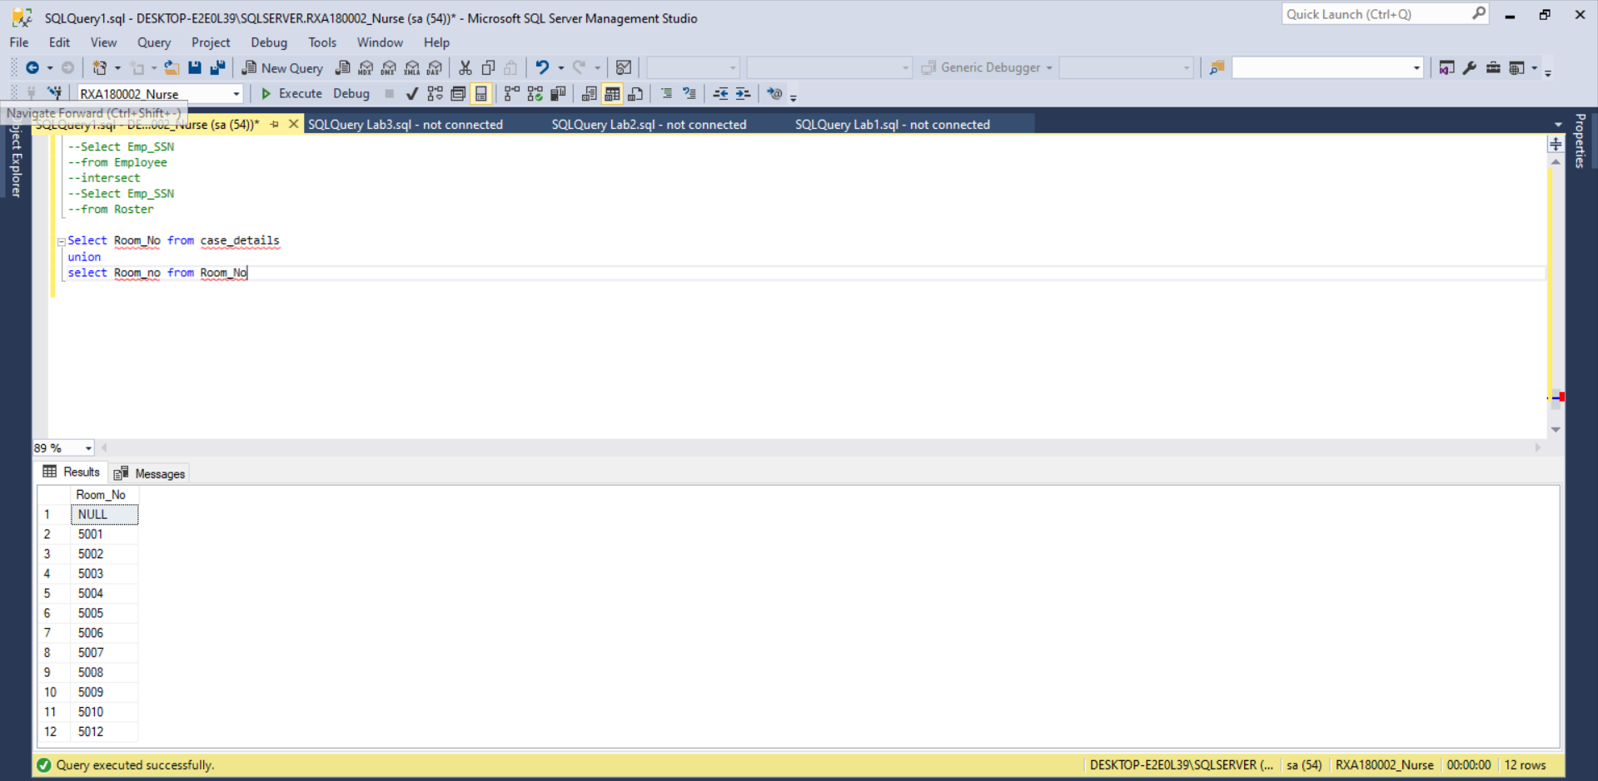 h. Create except between two tables

